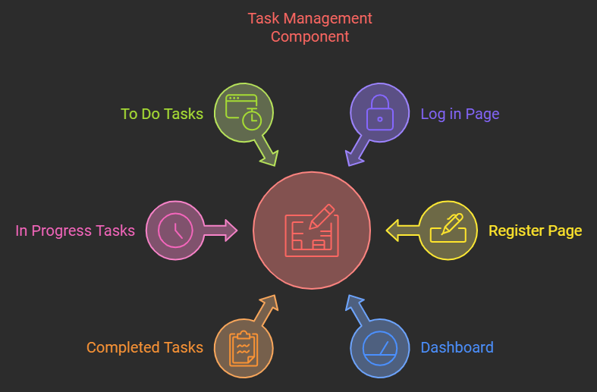

Task Management System Documentation

# Project Overview

The Task Management System is a web-based application that allows users to manage their tasks efficiently. It provides features like user registration, authentication, and a dashboard to view and manage tasks categorized as Completed, In Progress, and To Do. The project utilizes React.js for the front-end and Firebase for backend services such as authentication and database management.

# Why/Problem?

In today's fast-paced world, keeping track of daily tasks can be overwhelming, especially when using paper-based methods or basic digital tools that don't offer enough flexibility or responsiveness. Many existing task management tools are overly complicated or lack intuitive design, leading to inefficiency. This inefficiency hinders productivity and causes missed deadlines, forgotten tasks, or a cluttered workflow.

**Usage:**

The need for a simplified, yet effective task management tool arises from the challenge of balancing multiple responsibilities and priorities. Users often face difficulty in organizing their tasks due to a lack of easy-to-use digital systems that allow seamless management. The problem is further compounded by the absence of task reminders, real-time updates, and access across different devices. This project aims to address these issues by building a task management system that is simple to use, responsive, and efficient, helping users stay organized and focused on their daily goals.

**Background:**

The idea for the Task Management System stems from the common struggle of juggling various responsibilities at work, school, or personal life. The rapid advancements in web technologies such as React have made it easier to build efficient, responsive, and feature-rich web applications. React's component-based structure allows for a modular and maintainable codebase, which is ideal for developing a scalable task management system. This project leverages the power of React and local storage to create an effective tool that can serve users from all walks of life, helping them streamline their daily routines and focus on their priorities.

# Features

- User Registration: Users can create a new account with an email and password using Firebase authentication.

- User Login: Users can log in securely using Firebase authentication.

- Dashboard: The main interface that displays the total tasks and categorizes them as Completed, In Progress, or To Do.

- Task Management: Users can add, update, delete,search,change statues and categorize tasks based on their status.

- Responsive Design: The application is designed to be responsive, using Tailwind CSS for styling.

# Technologies Used

- React.js: The front-end library used for building the user interface.

- Firebase: Authentication, Firestore Database, and Hosting (for deployment).

- Tailwind CSS: For styling the components and ensuring a responsive design.

- React Router DOM: To manage navigation between pages in the application.

# Pages Overview

## Register Page

Allows new users to register with an email and password. Uses Firebase Authentication for handling user sign-up.

## Sign-In Page

Users can log in with their email and password. Firebase Authentication ensures secure login.

## Dashboard

Displays a summary of the total tasks. Links to pages showing tasks by status: Completed, In Progress, and To Do. Shows task cards with options to update or delete tasks.

## Task Management Pages

- Completed Tasks: Displays tasks marked as completed.

- In Progress Tasks: Shows tasks currently being worked on.

- To Do Tasks: Lists tasks that are yet to be started.

# Task Flow

1. User Registration/Sign-In: New users must first register to create an account. Existing users can log in via the sign-in page.

2. Task Creation: Once logged in, users can create tasks using the "Add Task" popup.

3. Task Management: Tasks are displayed in their respective categories (Completed, In Progress, To Do) on the dashboard. Users can update the status or delete tasks as needed.

# Future Improvements

- Implement push notifications when there are a not completed tasks.

- you can click the ✅ sign on to do or in progress tasks to have a complete tasks.

- you can search on tasks in each page (Completed ,In progress and to do pages).

- when click on user pic you can see username and user email also you can log out.

Use Case Diagram

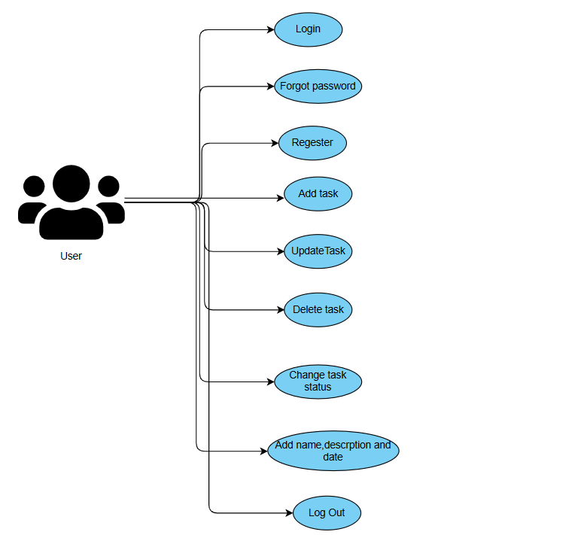

you can access the wireframe at : [task management system project](https://www.canva.com/design/DAGSo4mOPbw/PgETclNXxgjlHsjTme-pmQ/view?utm_content=DAGSo4mOPbw&utm_campaign=designshare&utm_medium=link&utm_source=editor)